# SCD – Dec-28-2013 (v 0.87)

## Layout Changes

* Per request I decreased the tab width on the left side of the screen to the minimum possible (see image below). Remember: The user can further decrease\increase using the highlighted buttons at the bottom right-hand corner of the screen (next to the magnifier).

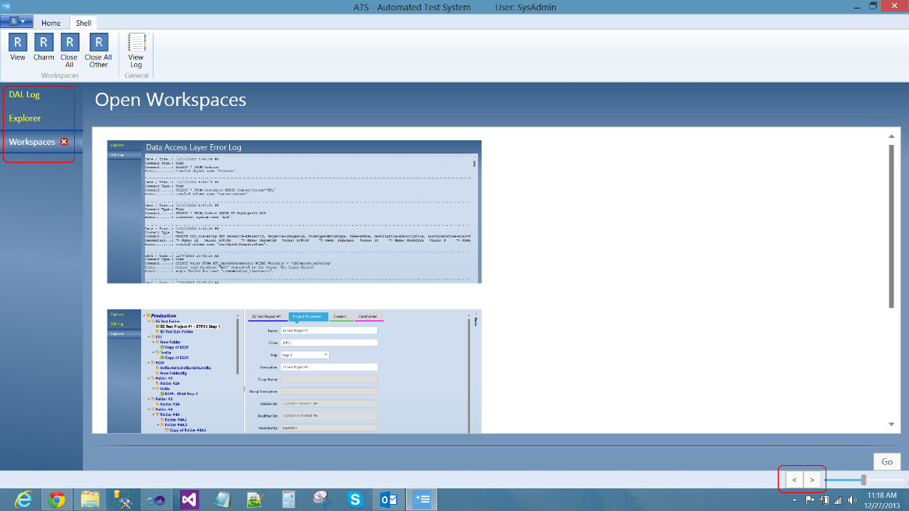

* Reduced Tree width (as much as possible without affecting Search area too much) and made other changes requested (that I could do without big effort):

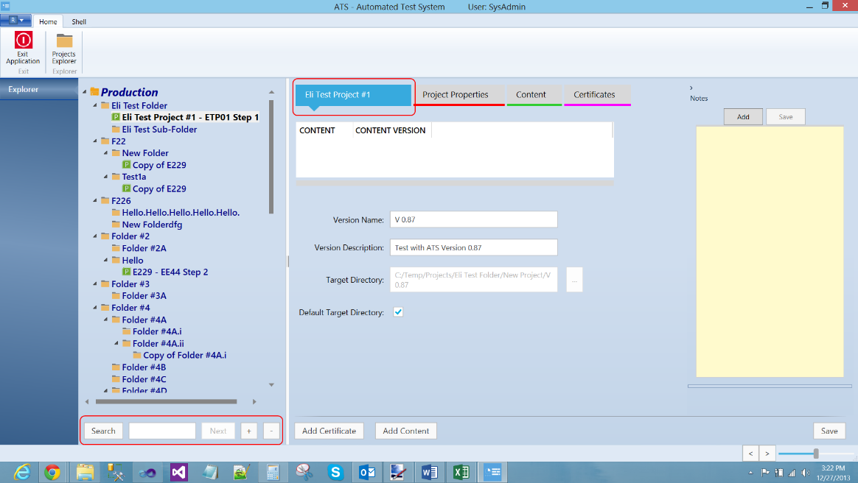

## Other work done

* I disabled several menu options per bug# 1617. Rotem – Be aware that I was requested to disable Show Versions; I did it in the XAML only, so consult with Ella on if\when to re-instate it.
* I re-wrote the entire Project Suspend \ Resume methods; it is now working as it should be, including the Icon, with ~1/3 of the # of lines. Please read my Comments section below and do the same for other areas I didn’t ‘catch’ yet…

## Comments

* All – One thing I see that you keep on doing wrong is the way you update entities. As you recall, our layered design is such that we have a UI, which interacts with the ViewModel, which interacts with the Business Logic Layer, which interacts with the Data Access Layer. You can (technically) call the DAL from the VM, but this is wrong and creates a mess. Every layer should only communicate with the layer below. A wrong way of doing things can be seen in the way Project Status is being updated when a Project is disabled or resumed. Currently the TreeViewProjectNodeViewModel is issuing an update statement from within the VM in case of Open, and another one in case of Disable. Instead, Rotem, you should have created a method in HierarchyBLL called UpdateProjectStatus and call this method with HierarchyId and the new status. In addition for this being ‘cleaner’, we could also use this new method as an API in case SCD would want to set the project status from their system. Please go thru the code, systematically, and make these changes. Rotem – I did it for Project Disable \ Resume.
* I see we still have bugs in D&D of both Content and Certificates. The Drop is still messing up the data; the Drop of Content is a big mess (causes all kind of errors in the database). In addition, when you go into an existing node with certificates you get the list of certificates double (every entry shows twice). Someone needs to seriously go over the Drop of both Certificates and Content and make sure that the logic is correct and there are no weird things happening in the UI or the database. Also, when you go to an existing Project\Folder, those lists should display properly the existing data from the database.
* Notes maintenance – Though technically working, there are certain UI issues. Alon, I am going to try and do something different (that might be more aligned with what Ella proposed). I will do it in a small sample project, and (hopefully I will be able to complete on time) send it to you and you will plug it in the main code with all the database activities.